Assignment 1

1.Explain the life cycle of applets with suitable diagrams.

->

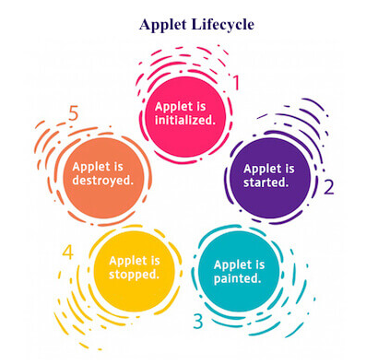

Life cycle of applet basically includes 5 methods which explains life cycle of Applet. The methods are: -

* init()

init() methods initializes applet. This is first method to be called and is called only once in entire life time of applet. It is called each time applet HTML document is display in screen. Declarations of variable and initializations are performed in this method.

* start()

start() method is used to start an applet after init() is invoked or initialized or when window is maximized. We can start applet in two conditions :-

i) until applet is destroyed

ii) when applet is in stop condition

* paint()

paint() method is called when AWT-based application output is to be drawn. The situation for occurring to call paint() method are:-

1) when window is overwritten by other window and uncovered.

2) applet window is minimized and restored

3) paint() is called when applet begins execution when needed to draw output

paint() has parameter which is of type Graphics.

* stop()

stop() method is used to stop the applet. When we minimize the window or stop the applet this method is invoked.

* destroy()

destroy() is used to destroy the applet. After applet has been destroyed we cannot start the applet again until it is again initialized. It is invoked only once.

2.Illustrate the applet skeleton.

-> Most trival applets override set of methods which provides basic mechanism through which browser or applet viewer interfaces to applet and control its execution. Init(), start(), stop() and destroy are four of these methods also cycle of applet.

Eg:-

import java.applet.\*; // applet class is present in applet package

import java.awt.\*; // contains component class which contains paint nmethod

/\*

<applet code="AppletSke.class" width="500" height="200"></applet>

\*/

public class AppletSke extends Applet{

    public void init(){

        System.out.println("Applet initilized");

    }

    public void start(){

        System.out.println("Applet started or execution start");

    }

    public void paint(Graphics g){

        g.drawString("Welcome to applet", 20, 10);

    }

    public void stop(){

        System.out.println("Applet stopped");

    }

    public void detroy(){

        System.out.println("Applet destroyed");

    }

}

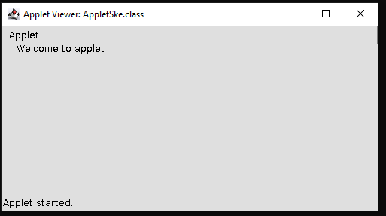

3.Write an applet program that displays your roll no, name and email address in three different lines.

->

import java.awt.\*;

import java.applet.\*;

/\*

<applet code="DisplayField.class" width="300" height="100">

<param name="name" value="Jojan">

<param name="roll" value="3990">

<param name="email" value="raijozan2443@gmail.com">

</applet>

\*/

public class DisplayField extends Applet{

    String name,roll,email;

    public void start(){

        name=getParameter("name"); //this assigns parameter value to variable

        roll=getParameter("roll");

        email=getParameter("email");

    }

    public void paint(Graphics g){

        g.drawString("Name is : "+name,0,10);

        g.drawString("roll is : "+roll,0,20);

        g.drawString("email is : "+email,0,30);

}

}

Output: -

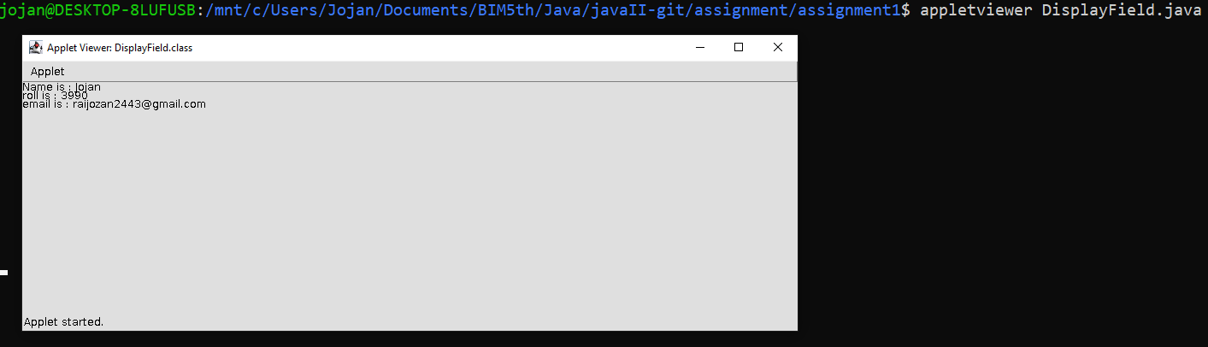

4.Write an applet program that takes a string as a parameter and checks whether the length of the string is less than 6 characters or not.

->

import java.awt.\*;

import java.applet.\*;

// Write an applet program that takes a string as a parameterand checks

// whether  thelength of the string is less than 6 characters or not.

/\*

<applet code="CheckLessThan.class" width="300" height="100">

// <param name="var" value="Jojannn">

// </applet>

\*/

public class CheckLessThan extends Applet {

    String varStr;

    int length;

    public void start(){

        varStr=getParameter("var");

        length=varStr.length();

    }

    public void paint(Graphics g){

        if(length<6){

            g.drawString("Less than 6", 0, 10);

        }

        else{

            g.drawString("Greater than 6", 0, 10);

        }

    }}

Output: -

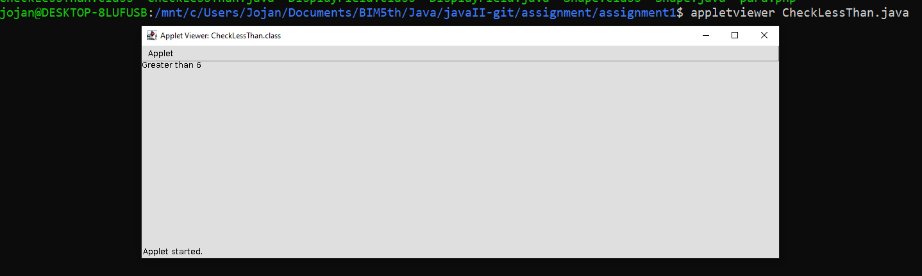

5.Write a program to create the following shapes: a.Rectangle with border color Red b.Square with border color Blue c.Circle with border color Green

->

import java.awt.\*;

import java.applet.\*;

/\*

<applet code="Shape.class" width="1000" height="500">

</applet>

\*/

public class Shape extends Applet {

    public void paint(Graphics g){

        g.setColor(Color.RED); //this is to set color

        g.drawRect(10, 10, 100, 50);

        g.setColor(Color.BLUE);

        g.drawRect(150, 10, 100, 100); //used rect for square with equal height and width

        g.setColor(Color.GREEN);

        g.drawOval(300, 20, 100, 100); //equal height and width for circle

    }

}

Output: -

